GUIDELINES FOR STAR TESTING REMOTELY

Assessment Dates: August 17 – September 4
The Monitor Password will be turned off by the teacher prior to testing their group of students, and set back as students finish testing. Please see instructions for disabling the monitor password below.
Teachers will utilize Microsoft Teams to virtually monitor student testing in small groups of 2-4 for younger students, 4-8 for older students.
Parents will be asked to be present in the room with the students to assist with logging in, and then will be asked to leave the room/area of testing once students get started.
Teachers will not change preferences (audio for Math, or extend time limits)
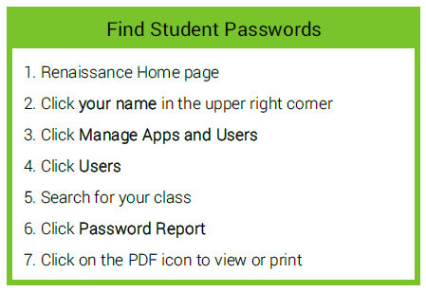
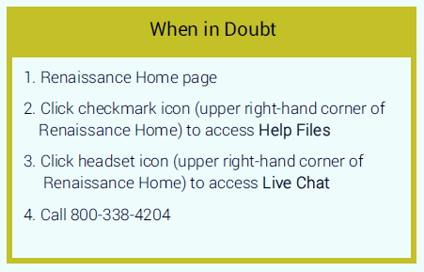
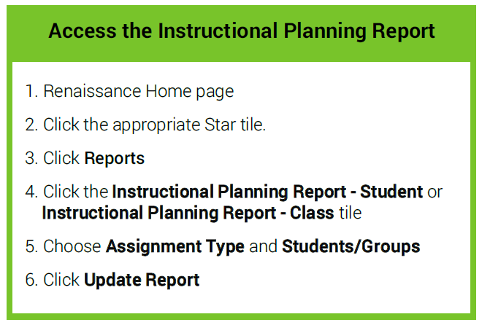
1. Renaissance Home page
2. Click appropriate Star tile
3. Click Preferences
4. Under Class Preferences click Password Requirement
5. Choose your Class and uncheck Before A Star test
6. Click Save Changes
Disable Monitor Password

